CS-340-T3341 Client/Server Development

2-1 CRUD in MongoDB

Eric Wallace

Jan. 15, 2023

1. To eliminate the need to have to access MongoDB from the virtual lab I downloaded the datasets, created a database on my Atlas server and added the collection there. Since I had quite a bit on experience with MongoDB, I found it to be easier than using the virtual lab. You will be able to see from my screenshots my personal atlas server information and if needed I can add you as a user so you can view the content.



1. Below are the attached showing the data was imported.

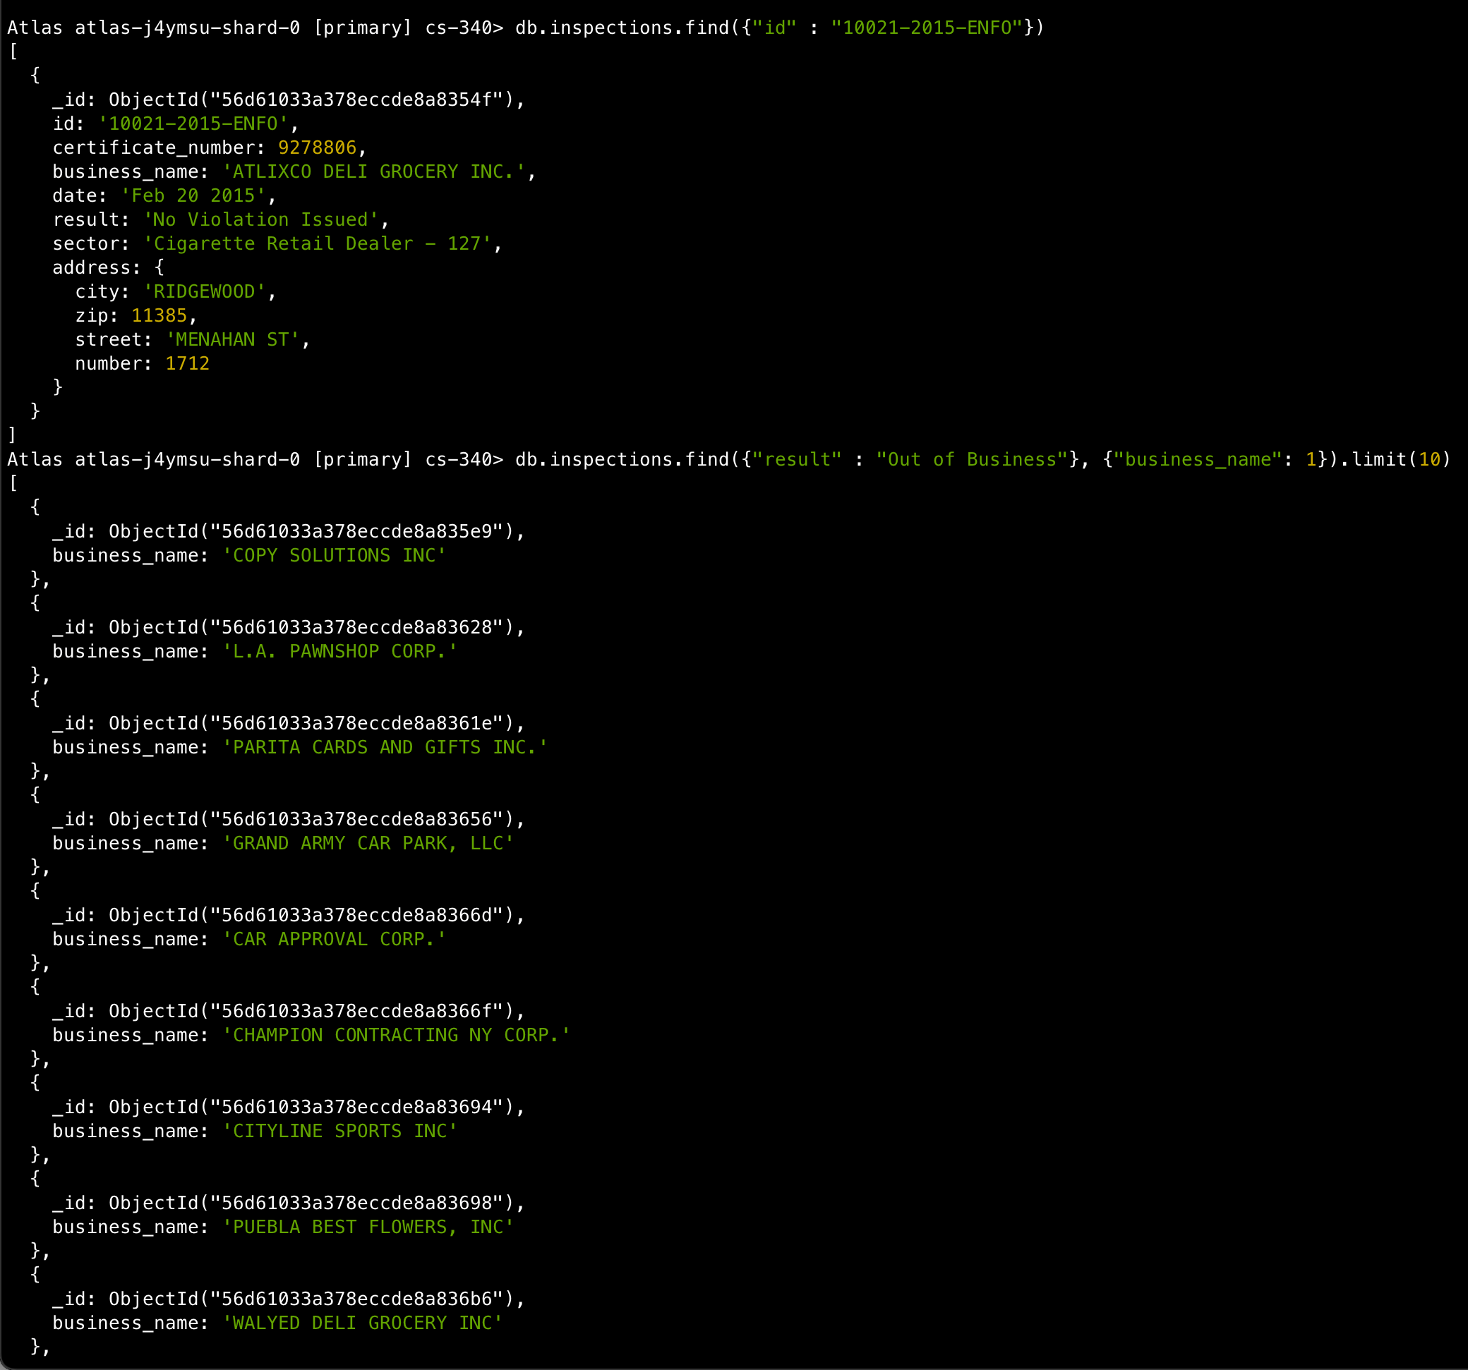

1. Inserted the new document with the address object. To get the sub-document I made address a object.

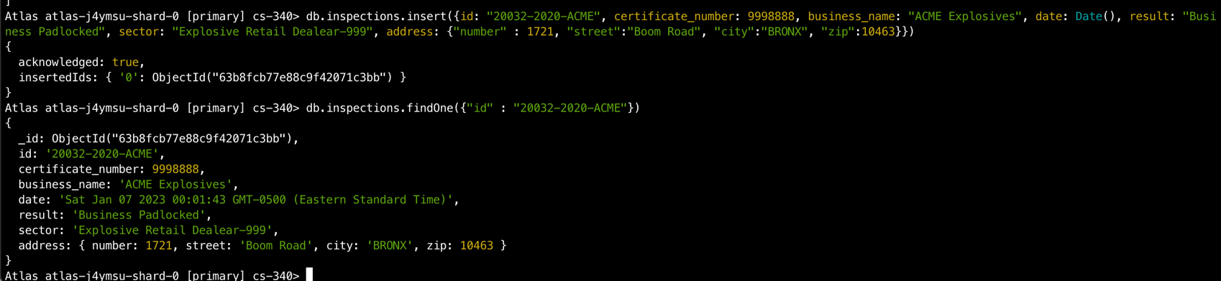

1. Please view each section below:
   1. There are 87 in the list of distinct sectors. This was found by using the distinct method.

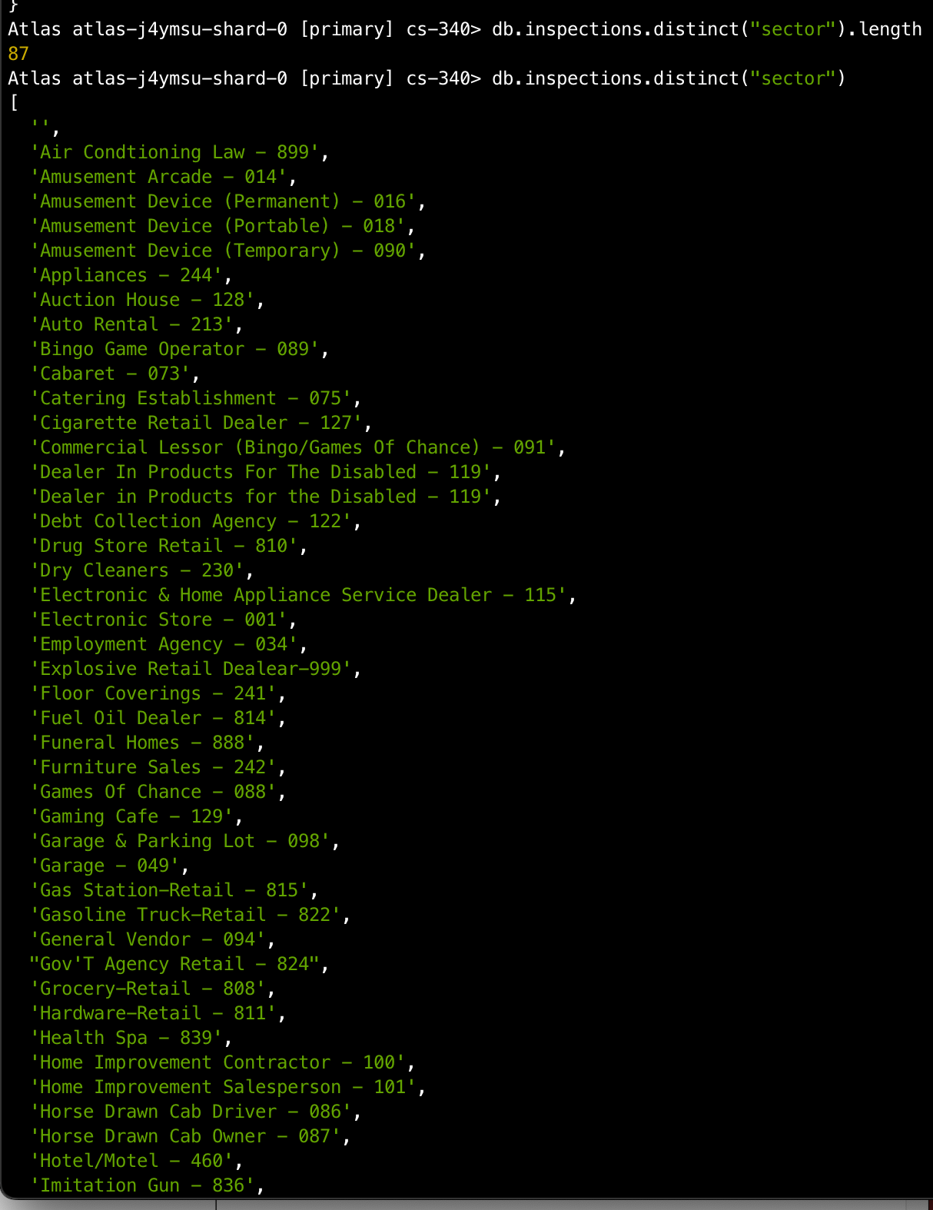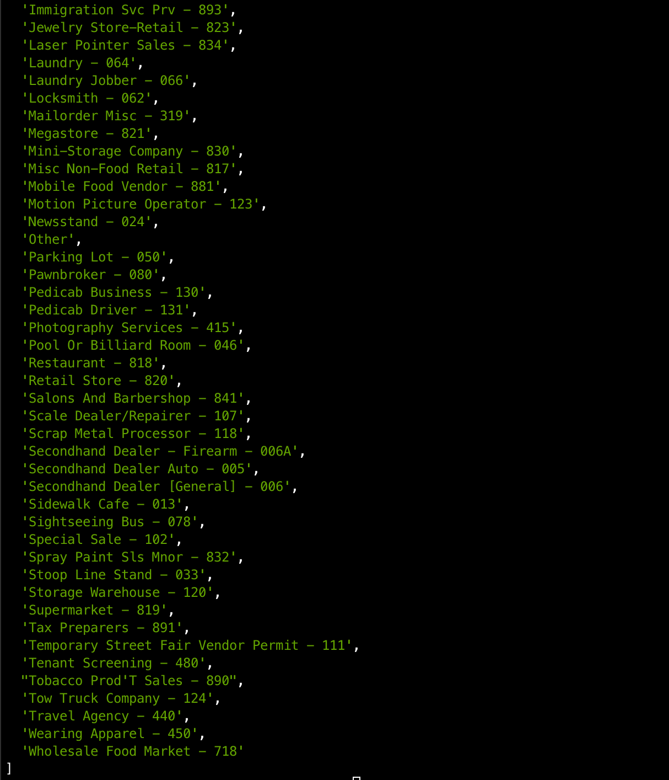

* 1. The difference between the date on the business named AUSTIN 2012 and the business name ACME Explosives is the date in AUSTIN 2012 is in the form of MM/dd/yyyy and ACME Explosives is in the form of DDD MMM dd yyyy hh:mm:ss



* 1. According to the screenshot below there was 13823 violations issued



1. Below is the screenshot of the update process and then the find to verify it was updated

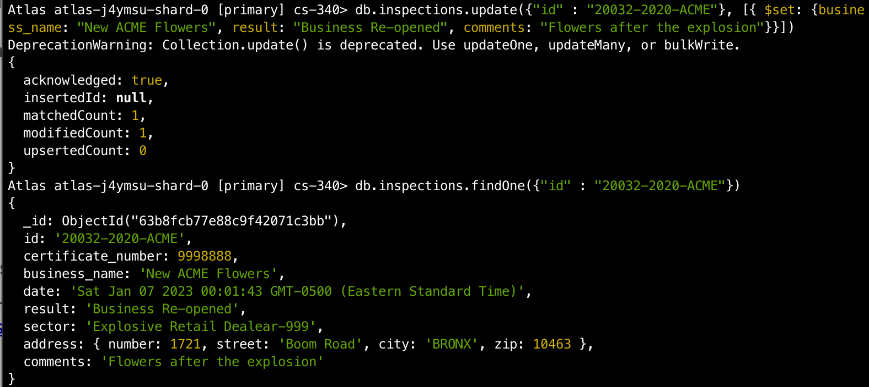

1. See the answers below
   1. As it can be seen there was 115 documents updated

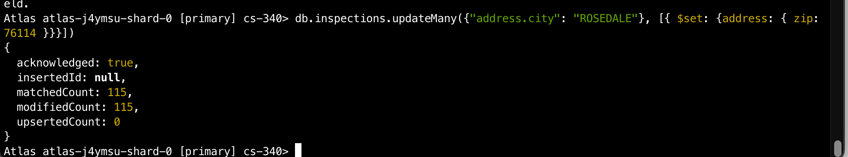

* 1. Using the deleteOne method it is confirmed one record was deleted

